
"Sam's Second Superpower"

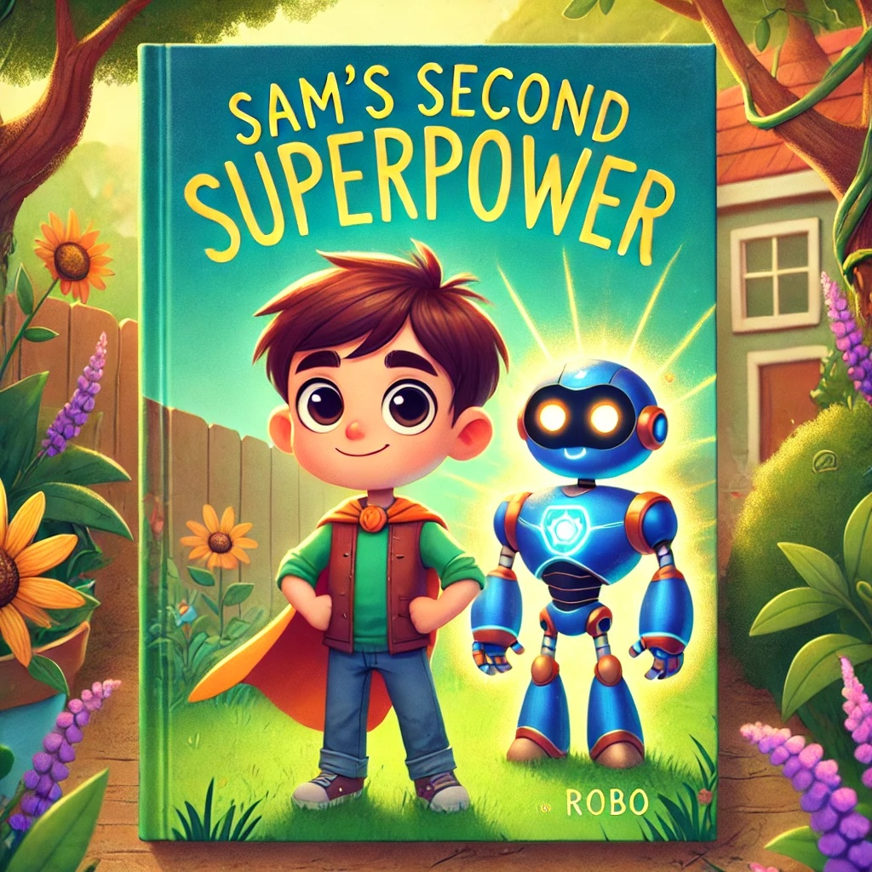

Chapter 1: Visiting the Science Lab

Sam and Robo were thrilled to receive an invitation to visit the local science lab. Sam eagerly put on his backpack, ready for the adventure. As they walked to the lab, they admired the beautiful sunset painting the sky in orange and pink hues.

At the lab, Dr. Spark welcomed them with a big smile. “Welcome, Sam and Robo! Today, we’ll explore science and learn about

compound words.”

Sam looked around the lab, amazed by all the cool equipment and gadgets. “This place is awesome!” he exclaimed.

Dr. Spark showed them a poster with pictures and words. “A compound word is made up of two smaller words. For example, ‘back’ and ‘pack’ make ‘backpack’. ‘Sun’ and ‘set’ make ‘sunset’.”

Sam repeated, “Backpack and sunset! I understand!”

“Great! Let’s start our science adventure,” Dr. Spark said enthusiastically.

With excitement, they began exploring the lab, touching and examining all the fascinating tools and machines. Robo’s eyes lit up with curiosity, beeping in delight at each new discovery.

Question: What two smaller words make up the compound word "backpack"?
Answer: "Back" and "pack".


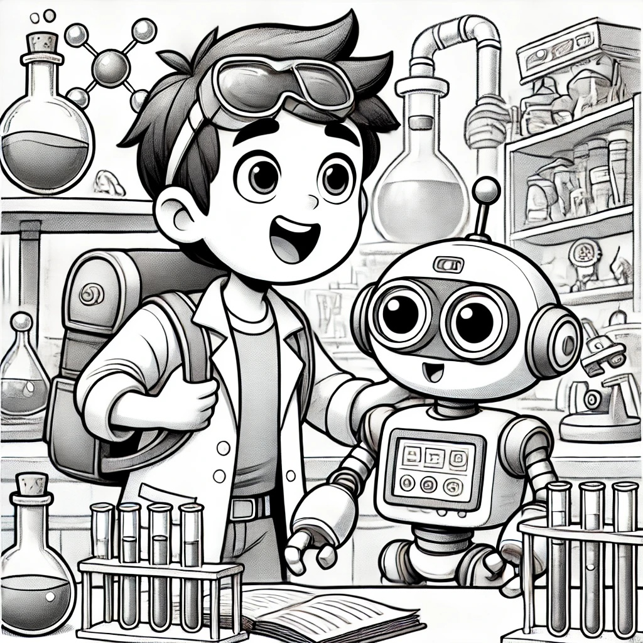

Chapter 2: Learning and Conducting the First Experiment

Dr. Spark led Sam and Robo to a big table filled with jars and bottles. “Today, we’re making a baking soda volcano!” he announced. Sam’s eyes widened with excitement.

“Come here, Sam, and look at this experiment,” Dr. Spark said, pointing to the setup. Sam and Robo stepped closer, eager to learn.

First, they put some baking soda into a small volcano model. “Now, we add vinegar,” Dr. Spark explained. He poured the vinegar, and the mixture started to bubble and fizz, creating a mini eruption.

“Wow, that’s amazing!” Sam exclaimed. Robo beeped in agreement.

“Remember the words ‘come’, ‘here’, and ‘look’,” Dr. Spark said. “Can you use them in a sentence, Sam?”

Sam thought for a moment. “Robo, come here and look at our volcano!”

“Perfect!” said Dr. Spark. They spent the rest of the day conducting experiments and learning new things, their laughter echoing through the lab as they marveled at each new discovery.

Question: What happens when vinegar is added to baking soda in the volcano experiment?
Answer: It creates a bubbly eruption.

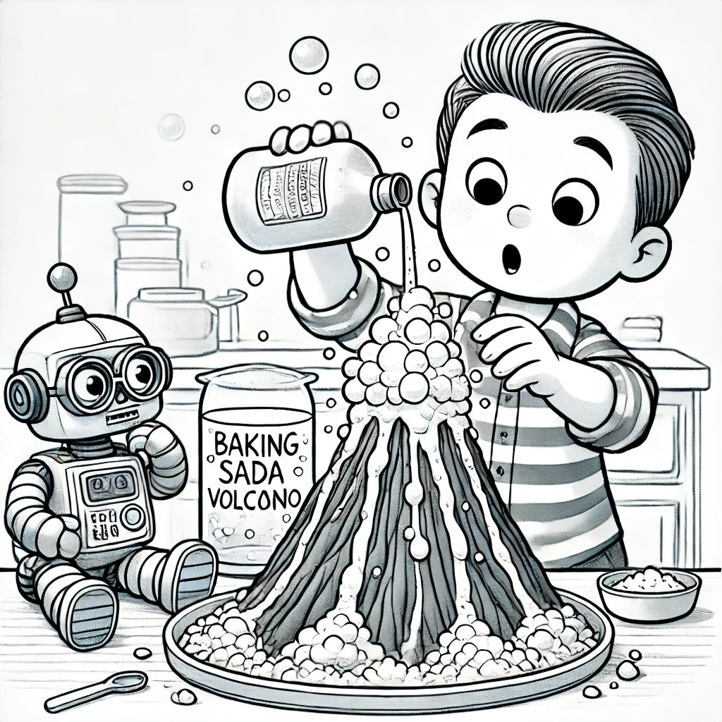

Chapter 3: Introduction to Healthy Habits

After the experiments, Dr. Spark gathered Sam and Robo. “Now, let’s talk about healthy habits,” he said. Sam and Robo listened closely.

“Exercise is very important,” Dr. Spark continued. “Let’s do some fun activities!” They started with jumping jacks and then moved to stretching exercises. Sam and Robo followed along, enjoying the movement.


Next, Dr. Spark showed them a plate with healthy snacks. “This is a sunflower seed sandwich,” he said. “Eating nutritious foods helps keep our bodies strong.”

Sam took a bite. “Yum! I like sunflower seeds,” he said, smiling.

“Let’s learn some compound words,” Dr. Spark suggested. “Sunflower and sandwich are compound words.”

Sam repeated, “Sunflower, sandwich.” He thought for a moment and said, “I planted a sunflower in my garden, and I made a sandwich for lunch.”

“Excellent!” Dr. Spark praised. They spent the rest of the session discussing healthy habits and practicing new words, dancing and singing about healthy foods and exercises.

Question: What compound word describes a healthy snack that Sam and Robo learned about?
Answer: "Sunflower"


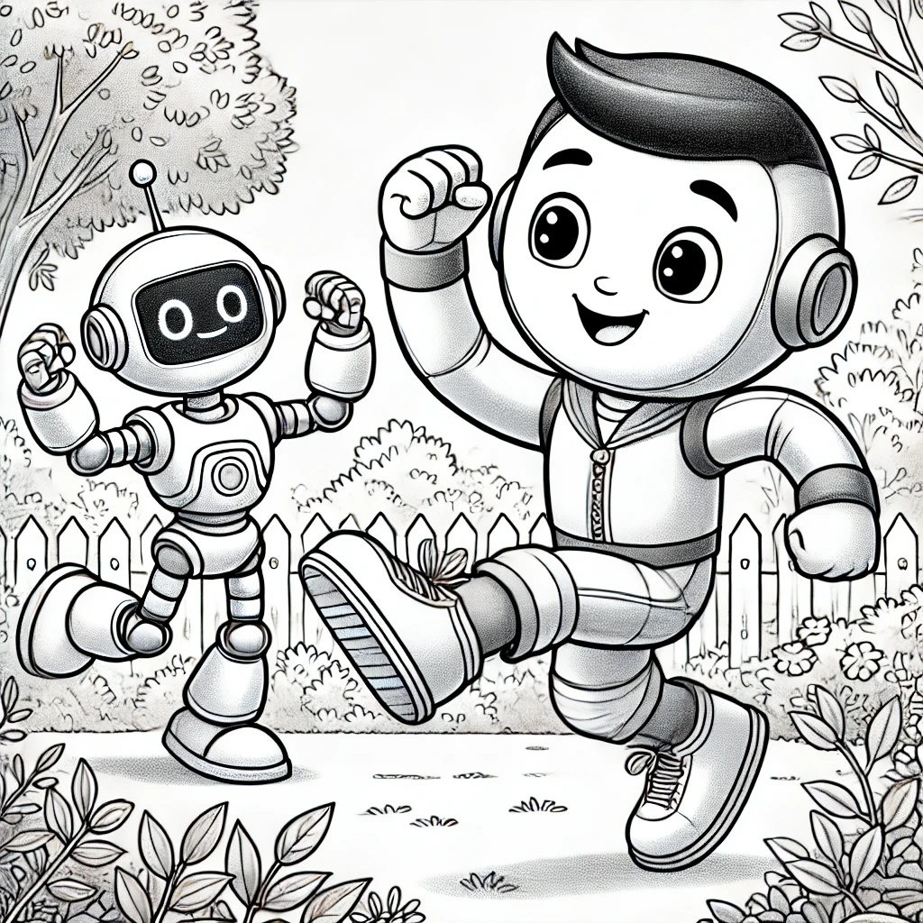

Chapter 4: More Experiments and Helping Friends

One sunny afternoon, Sam and Robo decided to help their friend Lily with a new experiment. Lily wanted to grow a sunflower plant in her garden. Sam and Robo were excited to help.

“First, we need some seeds, soil, and water,” Sam explained. They filled a pot with soil and planted the sunflower seeds. “Now, we need to water it,” Robo said, gently pouring water into the pot.


“We also need sunlight,” Sam added. They placed the pot in a sunny spot in the garden. “Sunflower plants need plenty of sunlight and water to grow strong.”

Lily was thrilled. “Thank you, Sam and Robo! I’ll take good care of my sunflower.”

Sam handed her a journal. “Let’s keep a journal to observe its growth. We can write down what we see each day.”

They started the journal together. “Day 1: Planted the sunflower seeds,” Sam wrote.

They continued to help Lily and watched the sunflower grow taller and stronger each day, learning new words like "sunflower" and "garden" as they went along. They sang songs about gardening and took turns drawing pictures of the growing plant in the journal.

Question: What do sunflower plants need to grow strong?
Answer: Plenty of sunlight and water.


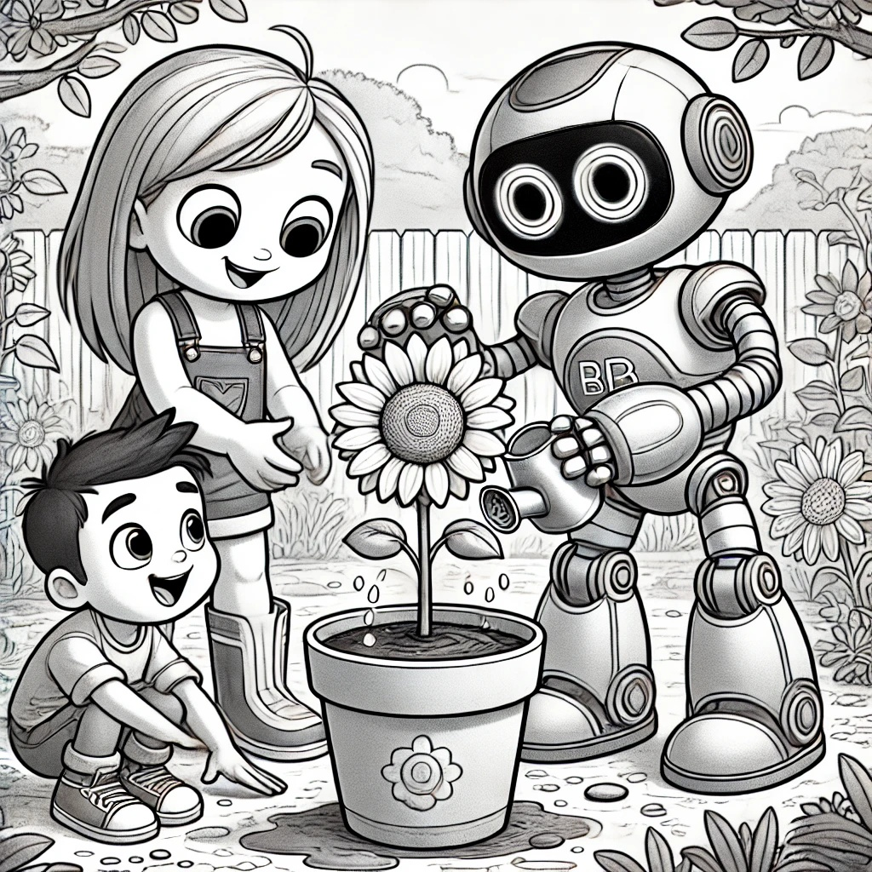

Chapter 5: Gaining the Ability to Perform Scientific Tasks

As the weeks passed, Sam and Robo continued to learn and grow. One day, Dr. Spark called them for a special meeting. “Sam, you’ve done an amazing job. You’re ready for a new superpower: the ability to perform scientific tasks!” he announced.

Sam was thrilled. “Wow! Thank you, Dr. Spark!”

“To celebrate, let’s review what we’ve

learned,” Dr. Spark said. He brought out a big poster with compound and sight words they had learned, like "backpack", "sunset", "come", "here", and "look".

Sam and Robo repeated the words, remembering their meanings. Then, Dr. Spark quizzed them on the science experiments they had done, like the baking soda volcano and growing the sunflower. Sam explained each experiment with confidence.

“Now, let’s use your new skills to help the community,” Dr. Spark said. “First task: fix a broken backpack!”

Sam and Robo got to work. Using their scientific knowledge, they quickly found the problem and fixed the backpack. “Done!” Sam exclaimed proudly.

“You’ve done great, Sam,” Dr. Spark praised. “Keep using your skills to help others.”

Question: What did Sam and Robo fix together using their scientific knowledge?

Answer: A broken backpack.

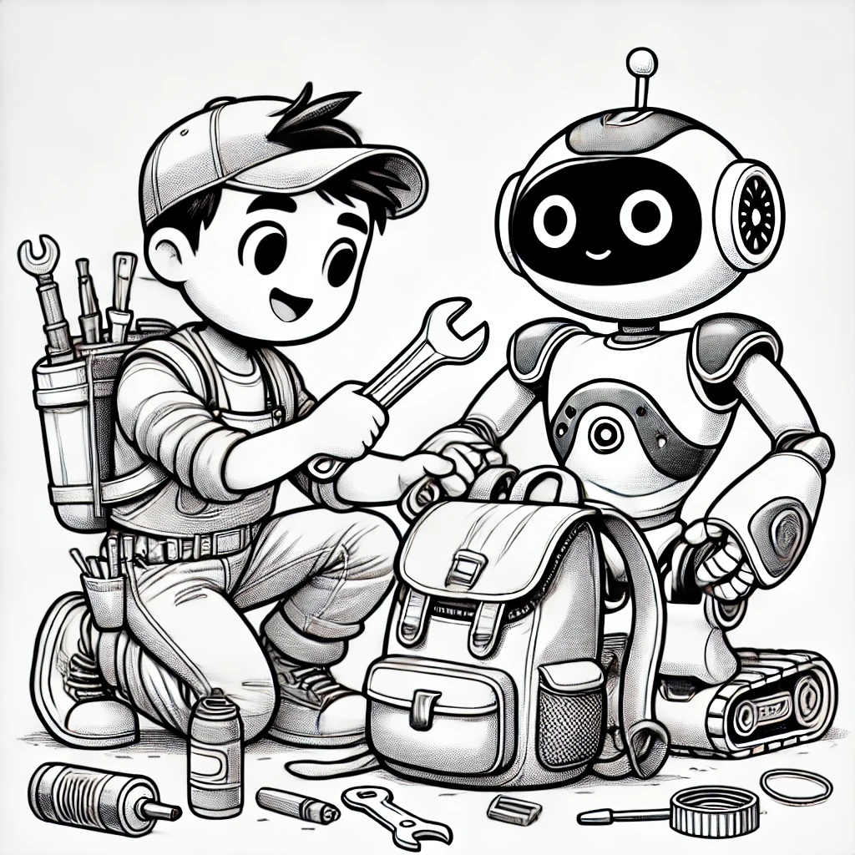

With his new superpower, Sam felt ready to tackle any challenge and make the world a better place. He and Robo danced with joy, knowing that they could make a difference with their newfound knowledge and skills. They set off on their next adventure, excited to see how they could help their friends and community even more.

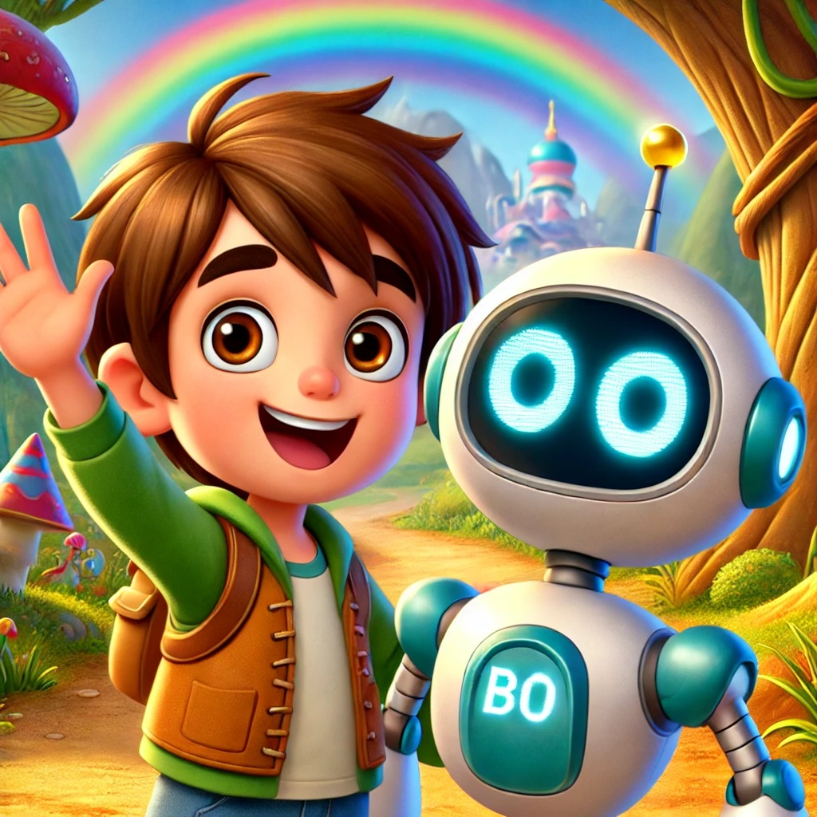

Wow, what an amazing learning journey! Keep up the great work and use your superpowers! We can't wait to see you in the next adventure. Thanks!"

